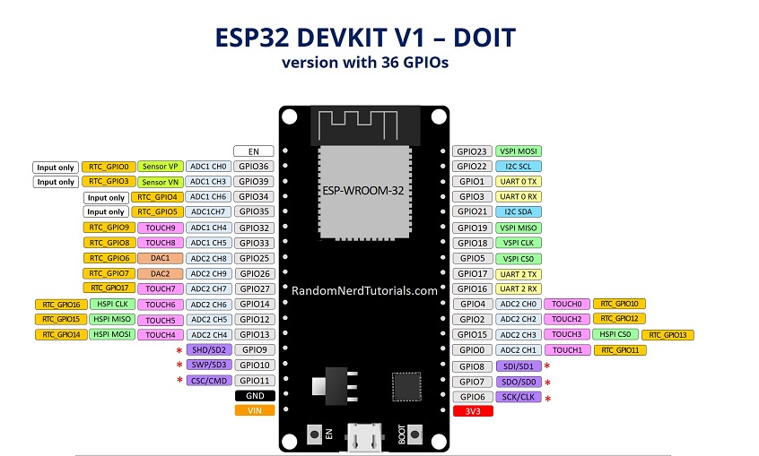

PIN Diagram (GPIO)

1. Buttons
   1. Start button - 33
   2. Enter - 25
   3. Back - 26
   4. Up - 27
   5. Down - 14

1. Temp sensor ( 34,35,36,39 )
   1. Sensor 1 - 34
   2. Sensor 2 - 35
2. LCD ( i2c )
   1. SCL - 22
   2. SDA - 21
3. Solenoide
   1. Boil solenoid - 18
   2. Cooler sole - 17
   3. Tank sole - 4
   4. Water out sole - 2
   5. Milk out sole - 15
4. Pump Relay
   1. Boil pump - 19
   2. Cooler pump - 5
   3. Tank pump - 16
5. Indicators
   1. Buzzer - 32
   2. LED 1 - 12
   3. LED 2 - 13